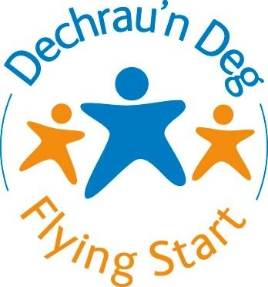
FLYING START CHILDCARE
APPLICATION FORM

Child’s Full Name

Child’s Date Of Birth | / /
Male Female
Child’s Permanent
Home Address
 | Postcode
Child’s Ethnicity
Does Your Child Have Any Disabilities or Additional Support Needs? | If yes please state -

Name Of Parent /
Carer
Parent/Carer’s Date of Birth
Parent’s Ethnicity
Any Disability / Health Problems? | If yes please state -
Email Address
Telephone Number | Home :  Mobile :
Language Used In The Home
Which language provision would be your preferred option for childcare?

English Welsh

Which nursery, playgroup or childminder would you like your child to attend?
Please tell us your first and second choice:
(Flying Start makes every attempt to meet your choice however we cannot guarantee that a place will be available at either Flying Start childcare provider. We will contact you if a place is not available at your choice)
1.
2.

If your child already attends a nursery, playgroup or childminder, please tell us the name of the setting your child attends.

Flying Start will only fund a maximum of 5 sessions of two and a half hours per week at ONE Approved Flying Start childcare provider.

Number of Sessions Required - 3 4 5

Please indicate if there are any days your child would not be able to attend the setting :

____________________________________________________________________________________________________

I have read and understood the accompanying privacy notice

Name of Person Providing Information: _____________________________________________

Signed: ________________________________________ Date: __________________________________

Relationship to the Child: _____________________________________________________________

Do you have Parental Responsibility for the Child?: _________________________________

Please return your application form along with a copy of your address and child’s date of birth evidence to:
Flying Start Childcare Applications
Westwood Centre
Tabernacle Street
Buckley
Flintshire
CH7 2JT
Or
Email : flyingstartapplications@flintshire.gov.uk
(Please remember to attach your address and child’s date of birth evidence which can be a scanned copy or photograph)

Once your childcare application form has been approved and a placement has been secured for your child, you will receive an email confirming a start date.
Funding will only be given from the date your application has been approved.

Flying Start Childcare Privacy Notice

Flying Start funds childcare provision for 2-year-olds from the term after their second birthday, to the term after their third birthday. Personal data will be processed by Flintshire County Council for the specific purposes of administering, monitoring and managing Flying Start Childcare. ‘Personal data’ may relate to the parent/s or child/children. The processing of your personal data is necessary as part of our Public Task defined by Welsh Government and in substantial public interest in order to deliver the Welsh Government Flying Start programme in Flintshire.
Flying Start and your chosen childcare setting are required to share personal data, which will be limited to only what is necessary for the delivery of the programme.
The Flying Start Childcare Team supports childcare provision for Flying Start funded children, and, in order to do this, may share relevant information about registered/funded children, including their attendance at settings and/or their development with other services such as:
- Health Visitors
- Early Entitlement
- Early Years and Family Support
- Inclusion
- Psychology
- Flintshire school staff
- The North East Wales Sensory Support Service
- Speech and Language Services
- Flintshire Pre-School Development Team

Where necessary, for the purpose of supporting your child’s learning and wellbeing, the Flying Start Childcare Team may also share information gained from the above services with the childcare setting your child attends.
Flintshire County Council will retain your data until your child’s 4th birthday and for a period of 6 years beyond that date. If you feel that Flintshire County Council has mishandled your personal data at any time you can make a complaint to the Information Commissioner's Office by visiting their website or by calling their helpline on 0303 123 1113. For further information about how Flintshire County Council processes personal data and your rights please see their privacy notice online.
http://www.flintshire.gov.uk/en/Resident/Contact-Us/Privacy-Notice.aspx

